COMP 6364 - Lab 1

1. Set the root password to "testing123\*"

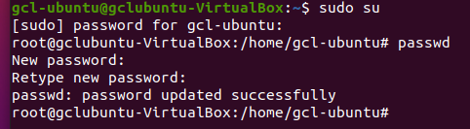

1. Log in as root.

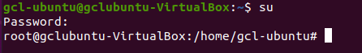

1. Create a new user called "uwi", password "testing123\*"

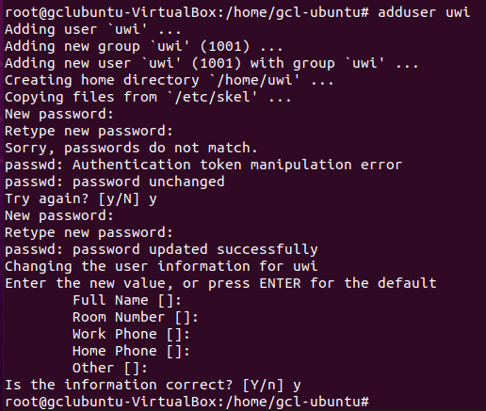

1. Create a file called "test.txt" with the content "test"



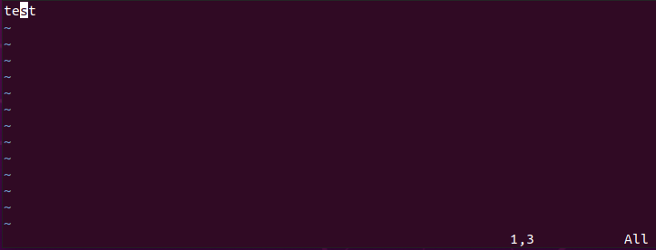

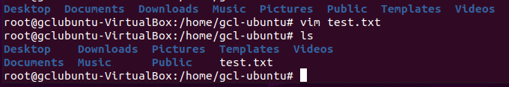

5. Display the OS information.

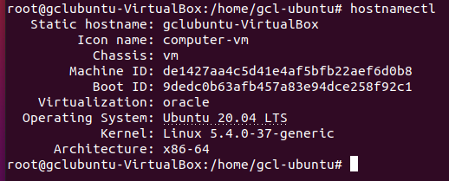

1. Using aptitude, run update and upgrade commands.

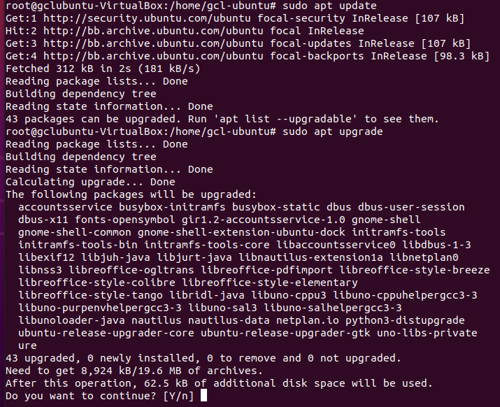

1. Read the man pages for chown and chmod



1. Change the permissions of your test.txt file to allow all users access.
2. Change the owner of your test.txt file to "uwi"



1. List the processes running on the system.

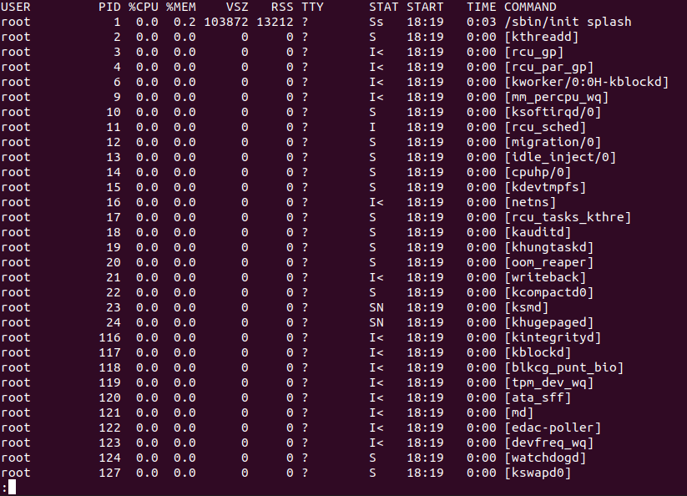

1. Read the man page for the kill command.
2. Start a process then kill the process





1. Display the date.



1. List the cronjobs currently in the system.



1. Create a cronjob to display, "end of class" at the end of the class.

 method 1

Method 2

